

Participant Guide

1. How to log in 2

2. How to access the MOOCs 4

3. Course Navigation 7

4. Checking your progress through the course 8

5.View announcements and events 10

6. Using discussion forums 12

7. Knowledge checks 15

# How to log in

* Login using your user name and password on NALA’s login portal: <https://learn.nala.ie/>
* You will be sent with this information through email.

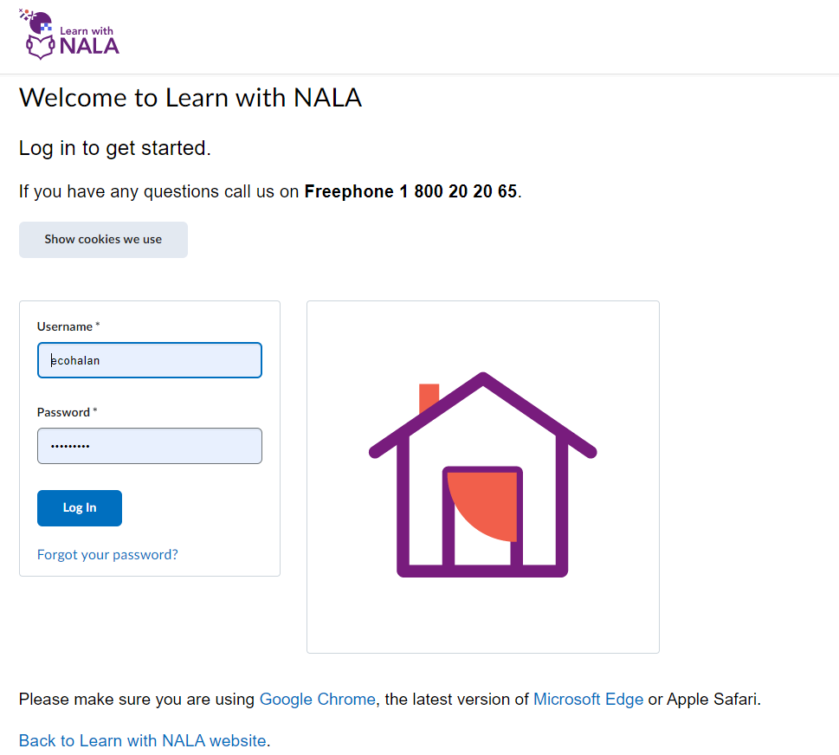

Your main dashboard will look like this.

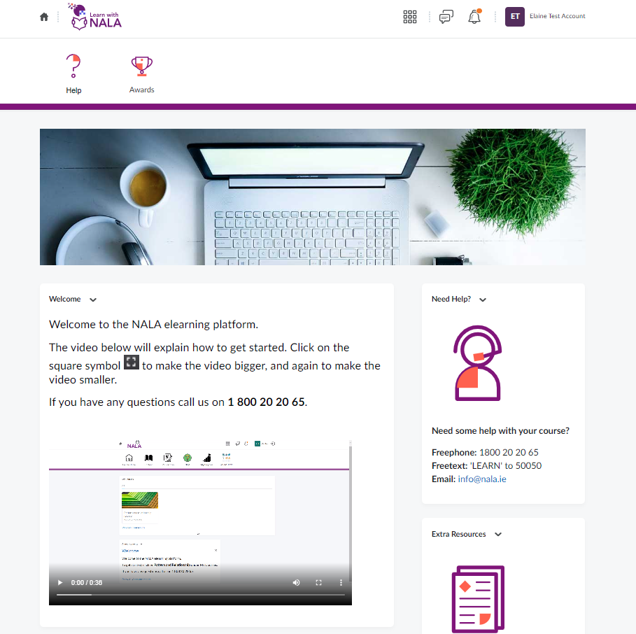

# 2. How to access the MOOCs

* Scroll down on your home screen to find the course you are enrolled on. Click on the course you wish to access.

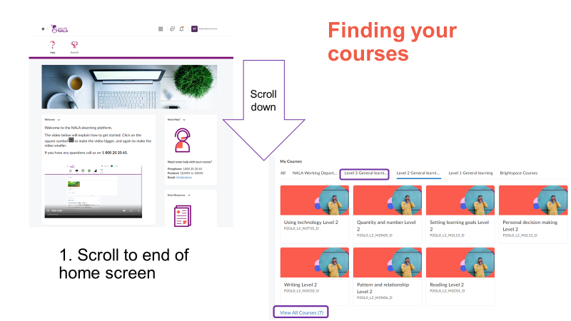

* This will take you to the course home page.
* To access the course content simply click ‘Content’ on the navigation menu.

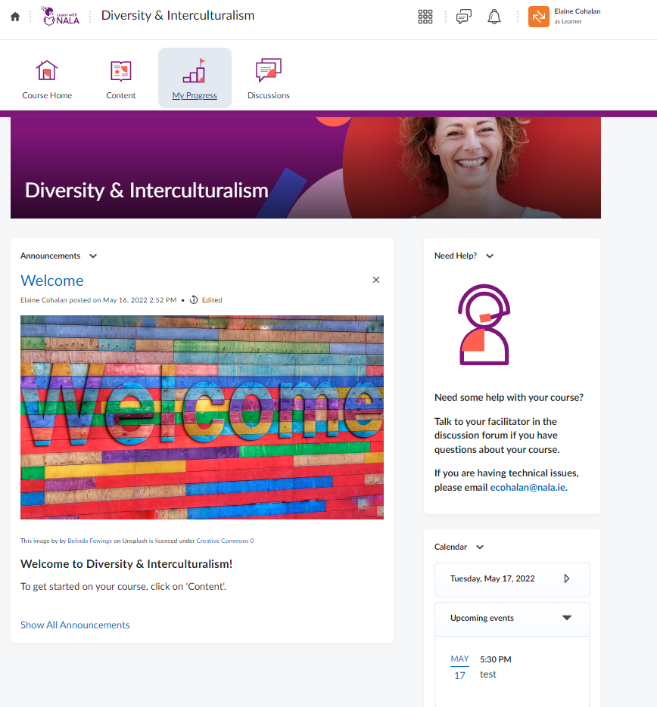

* Once you have selected content, you will see the below screen which is a table of contents linking to the course content.
* To get started, simply click ‘Get Started’. This will take you to the content screen.

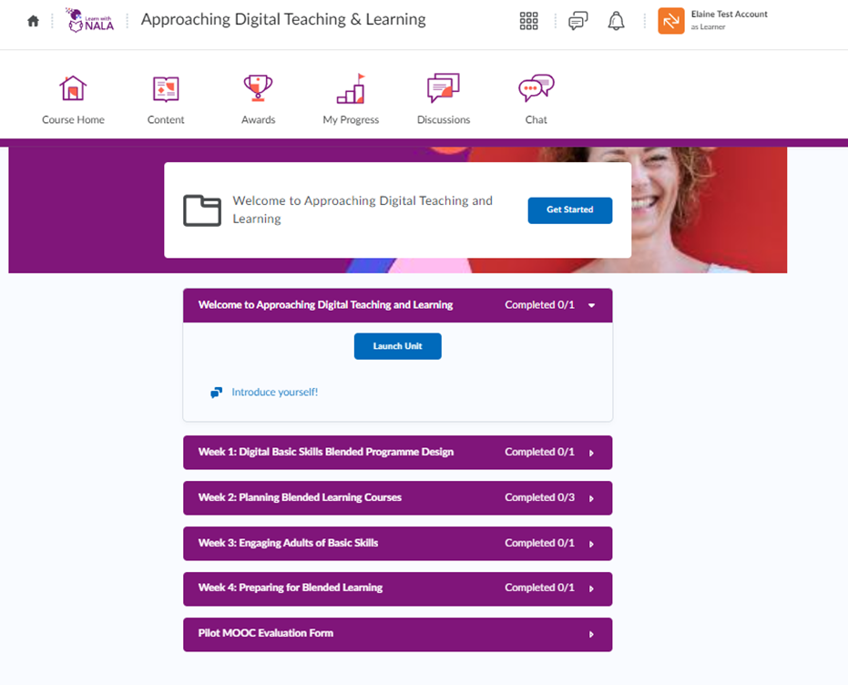

# Course Navigation

* You can use the arrows on the top right of the screen to navigate back and forth between screens.
* You can use the scroll bar on the right hand side to scroll through the content on this screen.
* At any time you can navigate back to the table of contents page by clicking ‘Back to Content’ on the top left of the screen.

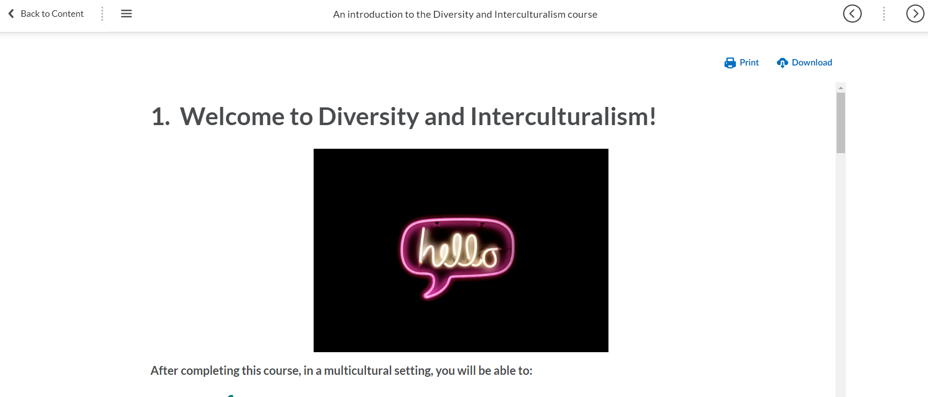

# 4. Checking your progress through the course

You can view where you are in the unit by clicking the  icon with three horizontal lines on the top left of the screen.

It is important to visit all of the pages on the course in order to get your certificate.

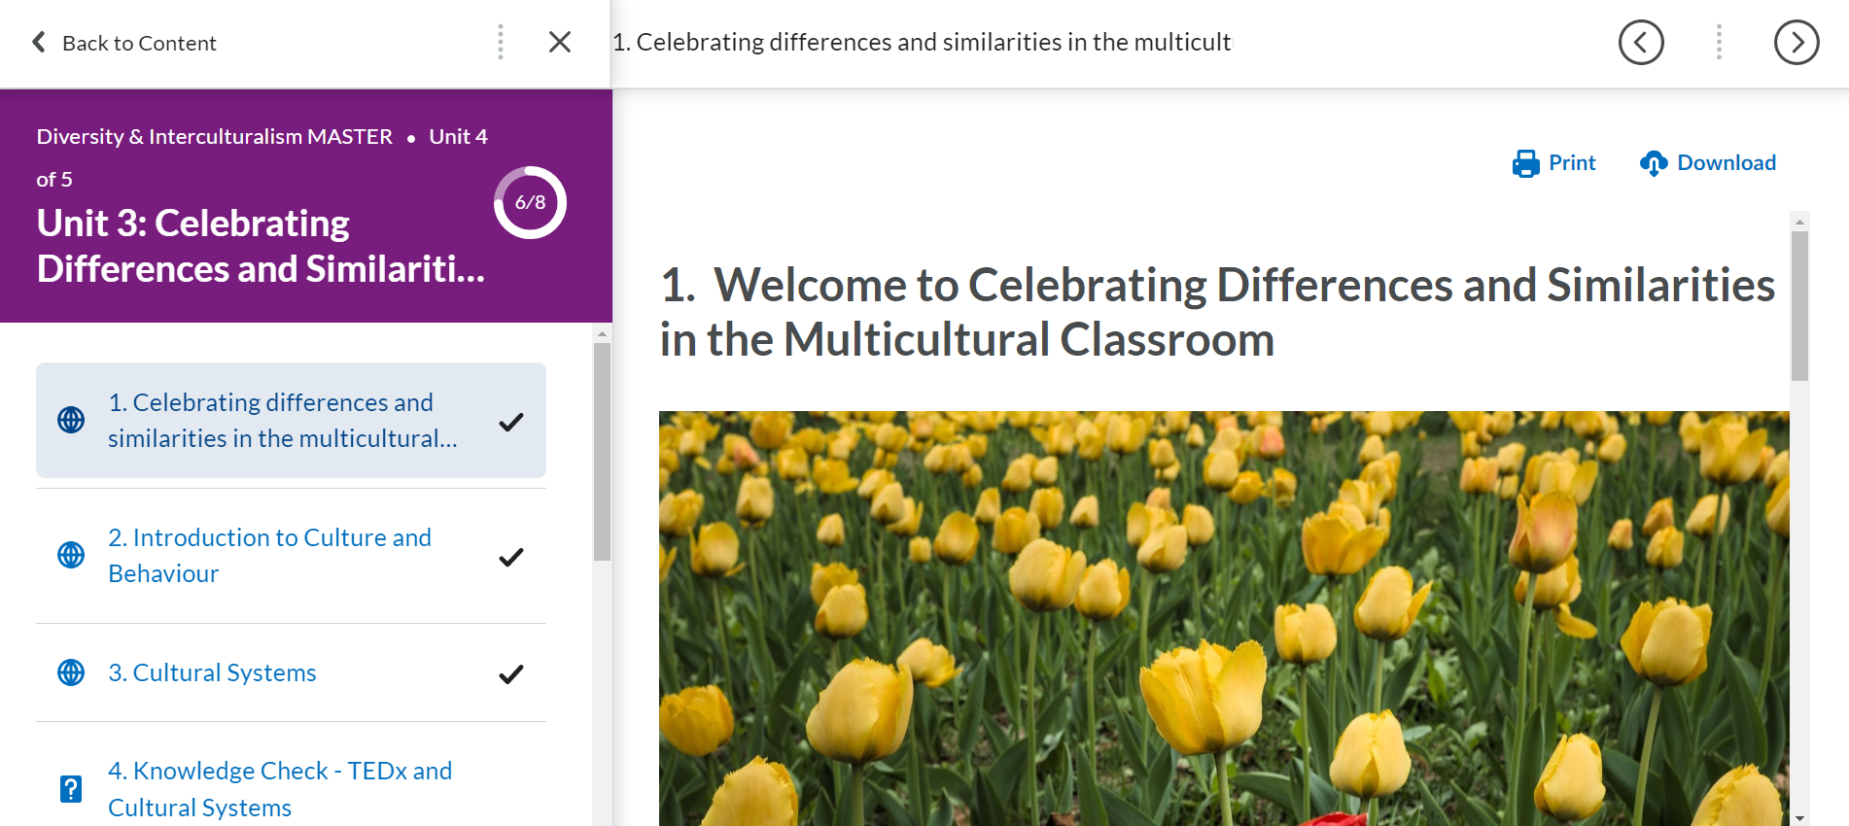

When you navigate out of the content, the table of content page will remind you where you finished and you pick up where you left of by clicking ‘Continue’.

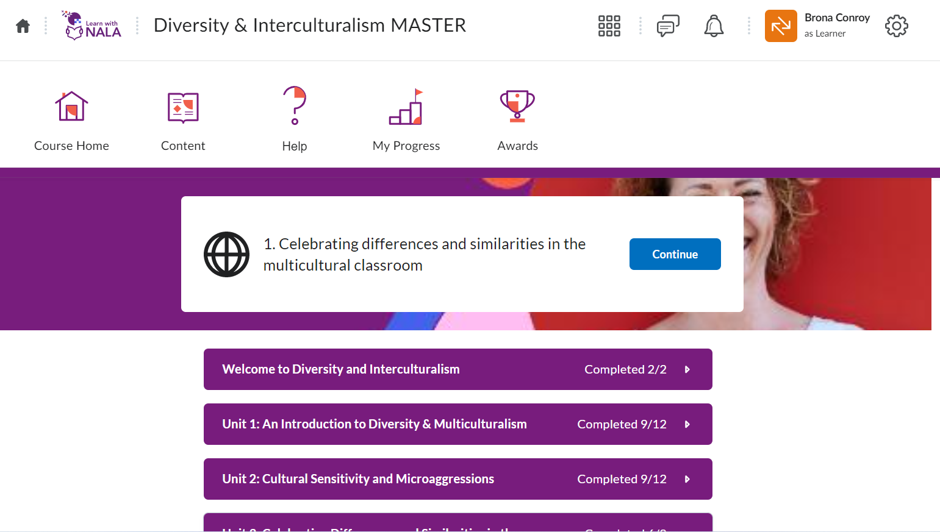

# 5.View announcements and events

* To view an announcement, or an upcoming event go to the course home page by clicking ‘Course Home’.
* Here you can view information on any announcements or events posted by your facilitator.

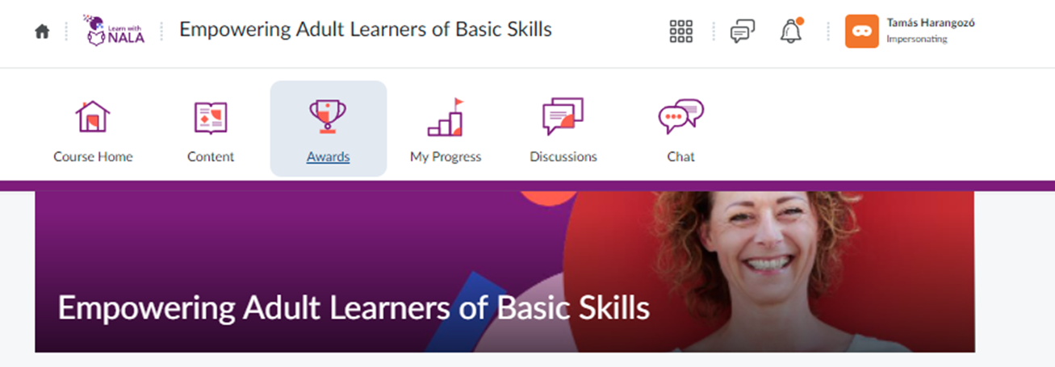

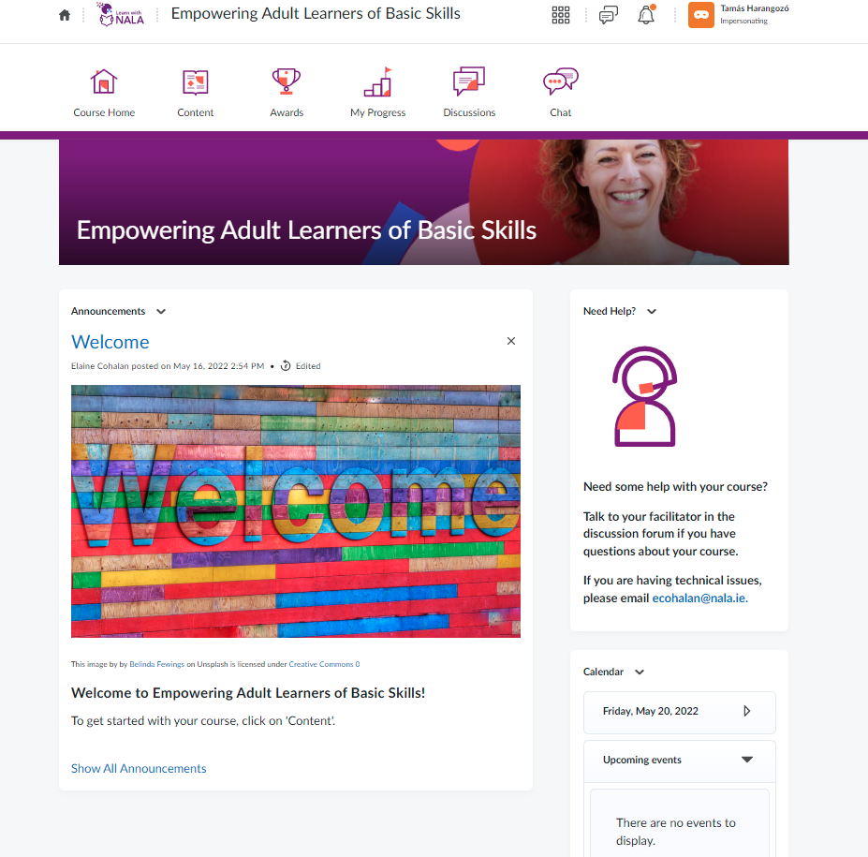

# 6. Using discussion forums

There are a number of discussion forums in each course. Your course facilitator will add topics here.

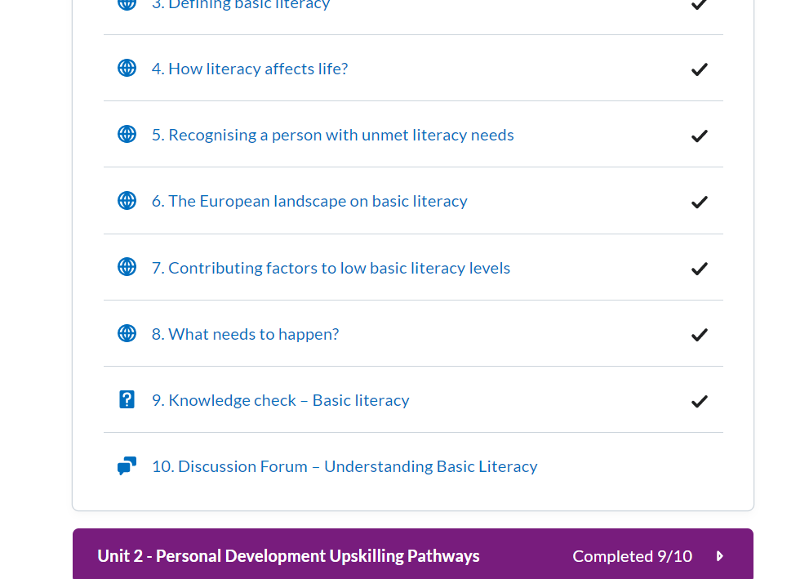

Click on the Discussion topic and **‘Start a new thread’** to post a comment.

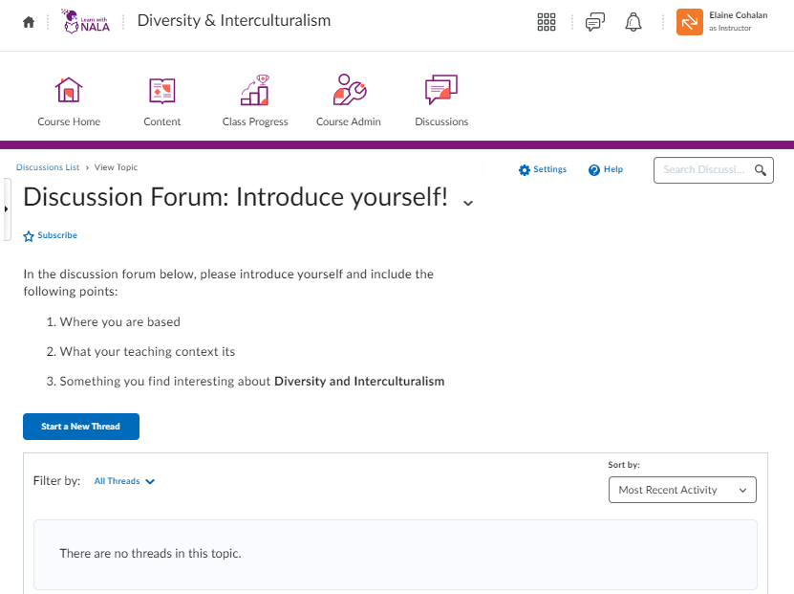

Click **‘Post’** for the comment to appear on the screen.

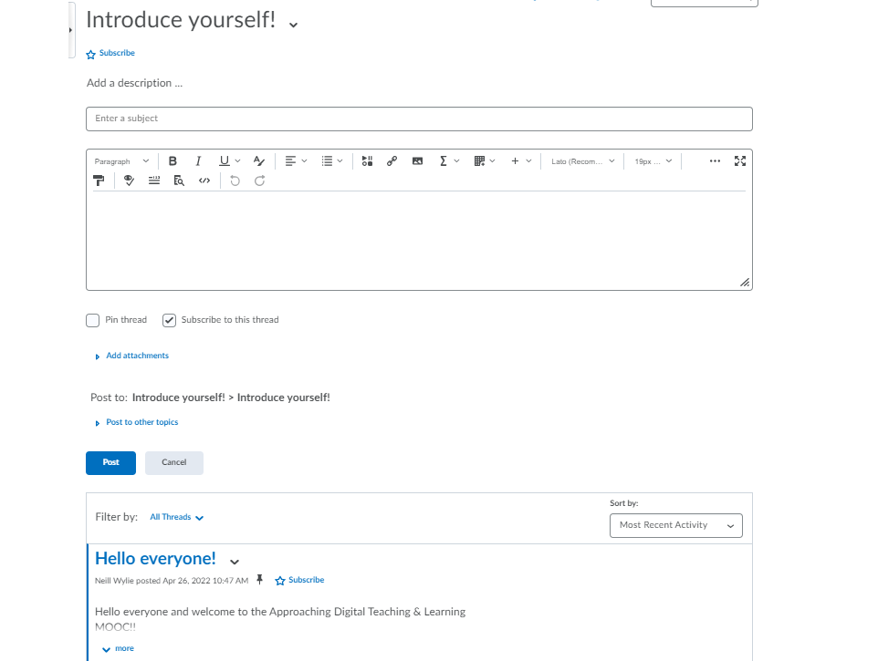

# 7. Knowledge checks

* Each course has knowledge checks which are ways to self-assess your progress in a course. You do not need to achieve a passing grade in a self-assessment to get your course completion certificate.



* To access a self-assessment in a unit, click **‘Go to quiz’.**
* You will get you results immediately.

